Right Triangle Trigonometry

Key Points:
- We can define trigonometric functions as ratios of the side lengths of a right triangle.

- Given a right triangle with an acute angle of t, the first three trigonometric functions are listed as follows:
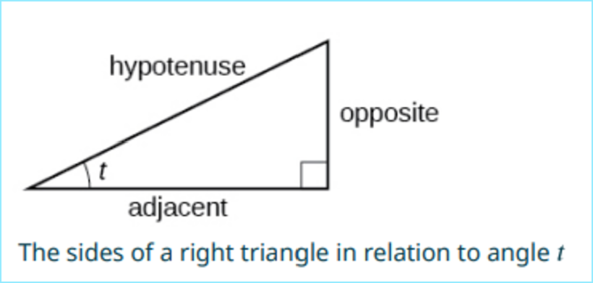
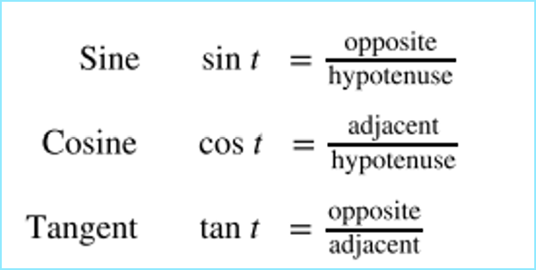
- A common mnemonic for remembering these relationships is SohCahToa, formed from the first letters of “Sine is opposite over hypotenuse, Cosine is adjacent over hypotenuse, Tangent is opposite over adjacent.”

- Trigonometric Function Values for Special Angles in a Right Triangle

$$t$$ | $$\sin{t}$$ | $$\cos{t}$$ | $$\tan{t}$$
$\frac{π}{6}$ or ${30}^{°}$ | $$\frac{1}{2}$$ | $$\frac{\sqrt{3}}{2}$$ | $$\frac{1}{\sqrt{3}} or \frac{\sqrt{3}}{3}$$
$\frac{π}{4}$ or ${45}^{°}$ | $$\frac{1}{\sqrt{2}} or \frac{\sqrt{2}}{2}$$ | $$\frac{1}{\sqrt{2}} or \frac{\sqrt{2}}{2}$$ | 1
$\frac{π}{3}$ or ${60}^{°}$ | $$\frac{\sqrt{3}}{2}$$ | $$\frac{1}{2}$$ | $$\sqrt{3}$$

Right Triangle Trigonometry Videos:
- Evaluating Trigonometric Functions of a Right Triangle: Examples 1-2
- Evaluating Trigonometric Functions of Special Angles Using Side Lengths: Example 3
- Finding missing lengths using Trigonometric Ratios: Example 4
- Measuring a Distance Indirectly: Example 5

Practice Exercises

Follow the directions for each exercise below:

- Use side lengths to evaluate $\cos{\frac{π}{4}}$.

- Use side lengths to evaluate $\cot{\frac{π}{3}}$.

- Use side lengths to evaluate $\tan{\frac{π}{6}}$.

- Find the lengths of the other two sides of the right triangle using the given information: $\cos{(B)}=\frac{3}{5}, a=6$

- Find the lengths of the other two sides of the right triangle using the given information: $\tan{(A)}=\frac{5}{9}, b=6$

For 6-7, use Figure to evaluate the trigonometric function:
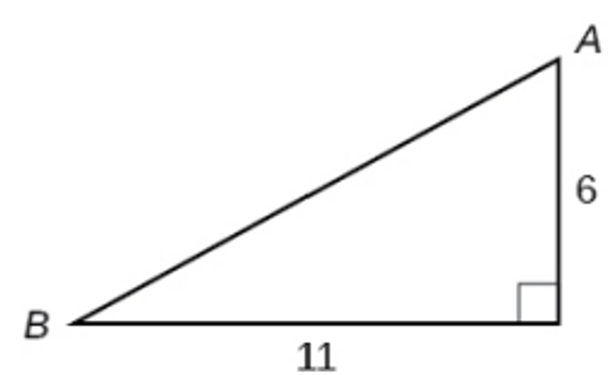

- $\sin{(A)}$

- $\tan{(B)}$

- Solve for the unknown sides of the given triangle:
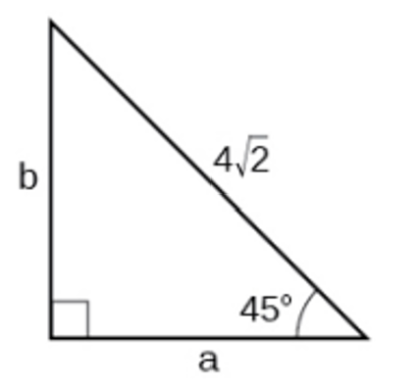

- Solve for the unknown sides of the given triangle:
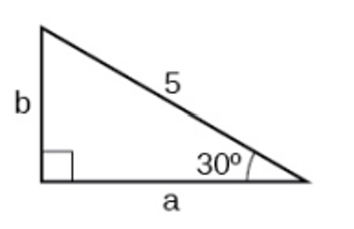

- A 15-ft ladder leans against a building so that the angle between the ground and the ladder is 70$°$. How high does the ladder reach up the side of the building? Find the answer to four decimal places.

- The angle of elevation to the top of a building in Baltimore is found to be 4 degrees from the ground at a distance of 1 mile from the base of the building. Using this information, find the height of the building. Find the answer to four decimal places.

- Find the missing sides of the triangle $ABC: \sin\left(B\right)=\frac{3}{4}, c=12$.

- Find the missing sides of the triangle:

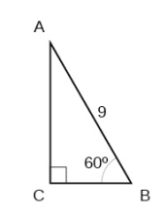

- The angle of elevation to the top of a building in Chicago is found to be 9 degrees from the ground at a distance of 2000 feet from the base of the building. Using this information, find the height of the building.

Answers:
- $\frac{\sqrt{2}}{2}$

- $\frac{1}{\sqrt{3}}$

- $\frac{\sqrt{3}}{3}$

- b=3, c=5

- $a=\frac{10}{3}, c=\frac{2\sqrt{106}}{3}$

- $\frac{11}{6}$

- $\frac{6}{11}$

- a=4, b=4

- $a=\frac{5\sqrt{3}}{2}, b=\frac{5}{2}$

- 14.0954 ft

- 369.2136 ft

- b=9, a=7.9373

- $a=\frac{9}{2}, b=\frac{9\sqrt{3}}{2}$

- 316.7689 ft

